**All Inclusive Setup Guide**

# **Introduction**

This guide includes the steps for setting up Anaconda, AirSim/Colosseum, and ROS for the Vitals Simulation project.

Most of the information is derived from [Ethan Adkin’s Setup Guides](https://drive.google.com/drive/folders/1IZvU67vZEsKxesKQG_45u9qEPoPj1gAT?usp=drive_link). This All Inclusive Setup Guide is to provide updated information and details for setting up the Vitals Simulation project all in one document.

The rest of the information is derived from the Microsoft AirSim documentation. Due to this project’s use of Colosseum, information is appended/modified to get Colosseum set up. Most of the instructions between AirSim and Colosseum are identical, but there are some slight modifications required.

# **Part 1: ML Environment + Simulator**

## **Anaconda**

Start by downloading and installing the Anaconda Distribution: <https://www.anaconda.com/download>. Leave all configurations as default.

Next, create a Conda Virtual Environment by following these steps:

1. Open the Anaconda Powershell Prompt (search for it in Windows Search Bar)
2. Type **conda create --name ml_env python=3.9**. *ml_env* can be any name of your choice.
3. Type **conda activate ml_env**. This will activate the *ml_env* virtual environment.
4. Install different machine learning packages in the environment:
   1. Type **pip install numpy**
   2. Type **pip install scipy**
   3. Type **conda install pytorch torchvision cudatoolkit=10.0 -c pytorch**
      1. This will install the GPU version of PyTorch. To install the CPU version of PyTorch, remove the **-c pytorch** at the end.
   4. Type **pip install opencv-python**

Verify that all packages/dependencies have been installed by typing **pip list**. This should contain all of the packages installed, including additional ones installed by the build wheel for PyTorch.

## **Prerequisites for AirSim/Colosseum**

Set up Git on Windows: <https://git-scm.com/downloads/win>

Set up C++ Toolset on Windows (I followed the MinGWx64 Example): <https://code.visualstudio.com/docs/languages/cpp>

Set up the latest version of CMake for Windows: <https://cmake.org/download/>

Enable and set up Windows Subsystem for Linux (WSL): <https://learn.microsoft.com/en-us/windows/wsl/install>

Next, install Unreal Engine by performing the following steps:

1. Download the Epic Games Launcher and register for an Epic Games account if you do not already have one.
2. Run the Epic Games Launcher and open the Unreal Engine tab on the left pane. Click on the Install button on the top right or click the + icon next to Engine Versions in the Library tab. In the new element that was created, select the version number to show a dropdown list and choose the necessary Engine Version. Click Install and follow the installation steps.
   1. **Colosseum** currently supports **Unreal Engine 5.4.4** (see note below)
   2. **AirSim** supports **Unreal Engine 4.27**

**Note:** Unfortunately, Colosseum does not have updated documentation to reflect changes. To see what version of Unreal Engine Colosseum currently supports, navigate to *Unreal/Environments/BlocksV2/BlocksV2.uproject*. Use the Unreal Engine version corresponding to the **EngineAssociation** key.

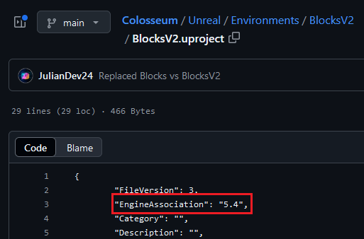

Finally, install Visual Studio 2022: <https://visualstudio.microsoft.com/vs/>

**IMPORTANT NOTE:** Currently, Unreal Engine 5 and Colosseum support VS version 17.11.X. This may be updated in the future, but at the moment, DO NOT UPDATE VS past 17.11.X. If you do, uninstall that version. You will have to install an earlier version here: <https://learn.microsoft.com/en-us/visualstudio/releases/2022/release-history#release-dates-and-build-numbers>

Currently, you must choose the Build Tools download under Current > 17.11.X

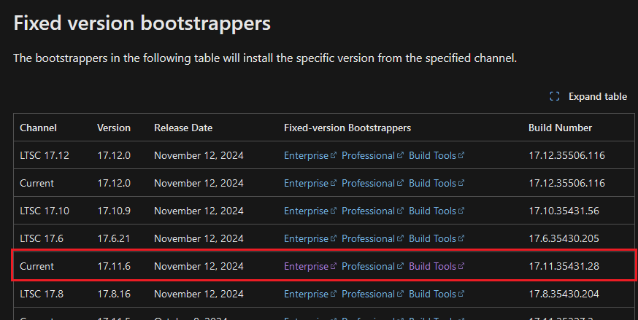

In the Visual Studio Installer, click Modify and modify the following:

* Select **Desktop Development with C++**.
* Select **Game Development with C++**
* In the Individual Components Tab:
  + Select **Windows 10 SDK 10.0.19041**
  + Select latest .NET framework SDK (for me, this is **.NET Framework 4.8 SDK**)
  + Ensure **.NET SDK** is checked.
  + Ensure **Visual Studio Tools for Unity** and **Visual Studio Tools for Unreal Engine** are selected.
  + Select **C++ CMake Tools for Windows**

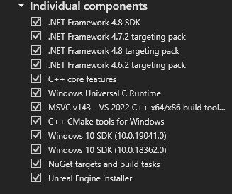

## **AirSim/Colosseum**

**Note:** These instructions are derived from <https://microsoft.github.io/AirSim/build_windows/> but include some modifications for Colosseum support.

Once Visual Studio 2022 is set up, start the **Developer Command Prompt for VS 2022** (search for it in Windows search bar).

In the Developer Command Prompt, clone the AirSim/Colosseum repository to your local machine. It is recommended to clone AirSim/Colosseum into a different drive from the C: drive, such as D: or E:. This is because cloning in the C: drive can cause scripts to fail, requiring VS to run in Admin mode.

* AirSim: **git clone** [**https://github.com/Microsoft/AirSim.git**](https://github.com/Microsoft/AirSim.git)
* Colosseum: **git clone** [**https://github.com/CodexLabsLLC/Colosseum.git**](https://github.com/CodexLabsLLC/Colosseum.git)

Once cloned, navigate to the AirSim/Colosseum directory by **cd AirSim** or **cd Colosseum**.

If using Colosseum:

* Download the [**build.cmd**](https://drive.google.com/file/d/1xhVUn18c8nl3KL3hFcEZGV27ZTuvx5de/view?usp=drive_link) from Google Drive and replace the one inside of the top-level Colosseum directory.

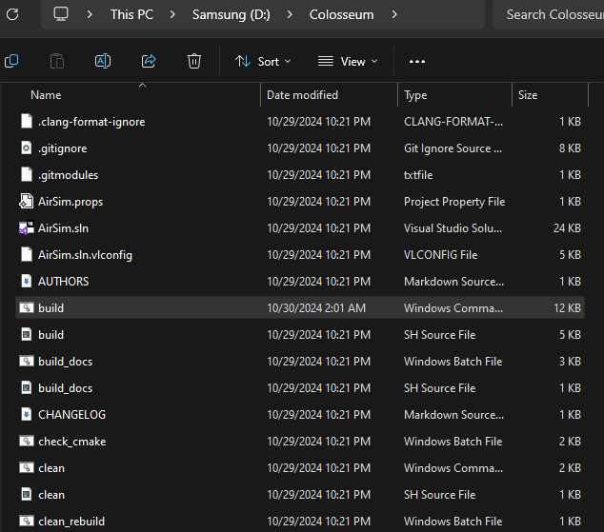

Now, in the Developer Command Prompt, navigate to the AirSim or Colosseum directory. Run **git submodule update --init**. Then, type in **build.cmd** to build AirSim/Colosseum.

Below are some errors that might come up while building Colosseum:

* If errors occur during “Check CMake Version”, ensure you downloaded the latest CMake installation from the Prerequisites for AirSim/Colosseum section. The CMake Installer in the Colosseum repo is out of date and does not include support for Visual Studio 17 2022.
* The build will always fail on the first try during the setup of “Eigen Dependency for AirLab”. Simply run **git submodule update --init** as directed and build again.

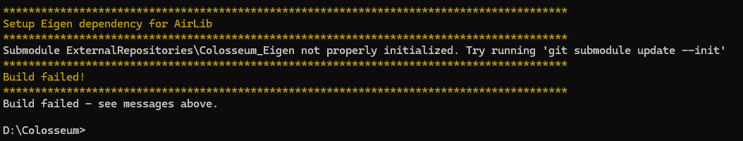

* If you get an error involving **HKEY_ROOT_CLASSES**, verify your Unreal Engine installation. In the Epic Games Launcher, click the dropdown next to the Engine version, and select **Verify**. If this doesn’t work, try the steps posted here: <https://github.com/Microsoft/AirSim/issues/519>



Once AirSim/Colosseum is built, test it in the sample Blocks project provided in the AirSim/Colosseum repository. Open Unreal Engine by starting the Epic Games Launcher, going to the Unreal Engine tab, select Library, and click “Launch” on the selected Engine version. In the Unreal Project Browser, select Browse… and navigate to D:/…/*Colosseum/Unreal/Environments/BlockV2* and open the **Blocksv2.uproject**.

On first opening the project, Unreal Engine may show a dialog box saying that BlocksV2 and AirSim modules are not currently built. Click **Yes** to build the project. If any errors occur, it is likely due to a mismatch in Engine Versions. Ensure the correct Unreal Engine version is installed based on the Prerequisites for AirSim/Colosseum section above.

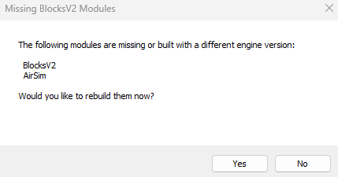

Once the BlocksV2 project is open, click the play button at the top. Select **No** in the dialog box to use the quadcopter. A quadcopter should spawn on the ground, not moving but propellers rotating. This means AirSim/Colosseum is set up and running.



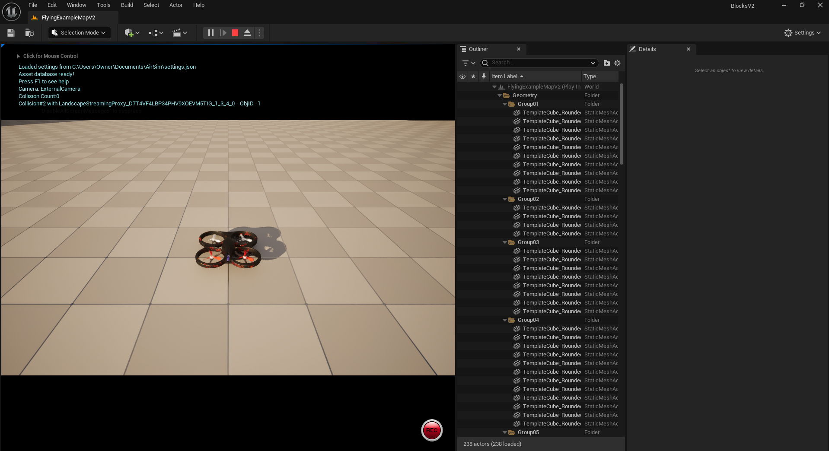

## **Interfacing AirSim/Colosseum with Python API**

Now that Anaconda and AirSim/Colosseum are setup, open up an Anaconda Powershell Prompt and navigate to the AirSim/Colosseum repository.

* If the repo is not on the C: drive, simply type the name of the drive to switch to it. For example, if the repo is on the D: drive, type **D:**.

Activate the Conda virtual environment by typing **conda activate ml_env** as before (or whatever the virtual environment name is).

Now, install this dependency: **pip install msgpack-rpc-python**

Then, install the airsim package: **pip install airsim**

* If an error occurs, it is because msgpack-rpc-python was not installed.

As a sanity check, type **python** and press enter to open a Python interpreter. Then type **import airsim** and press enter. If there is no error, then the airsim package is successfully installed.

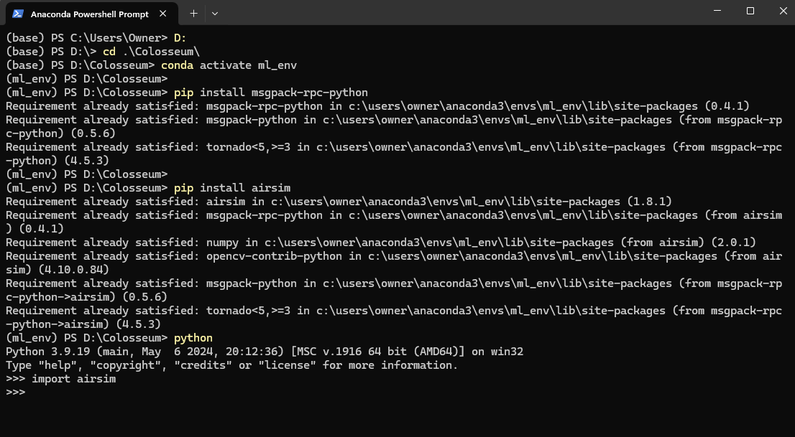

**Note:** I already had both packages installed, which is why Requirement is already satisfied.

## **Python API Example**

This section showcases an example of adding and using a Python script to interact with the simulator.

Start by navigating to *Colosseum\PythonClient*. This directory contains different directories like *computer_vision* and *multirotor*. Each of these directories contain scripts that can be run from the Anaconda Powershell Prompt.

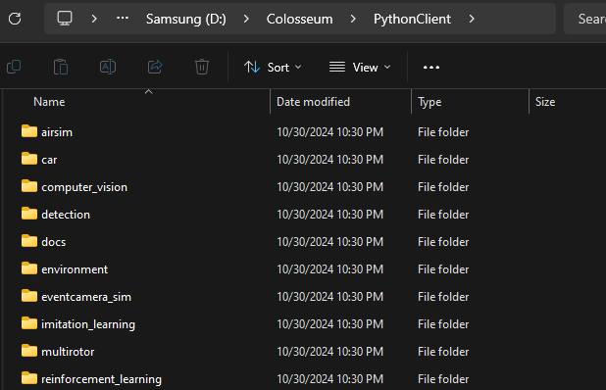

To use a Python script, follow the steps below:

1. Open and run the Unreal Engine simulator with the appropriate vehicle (in our case, this is quadcopter/multirotor)
2. In the Anaconda Powershell Prompt, navigate to the *Colosseum\PythonClient\multirotor* directory.
3. Run **python scriptName.py**, replacing *scriptName* with the file you want to run.

For example, to add a drone to the simulator, use the *add_drone.py* script in *Colosseum\PythonClient\multirotor*.

1. Run the simulator (Press the Play button)

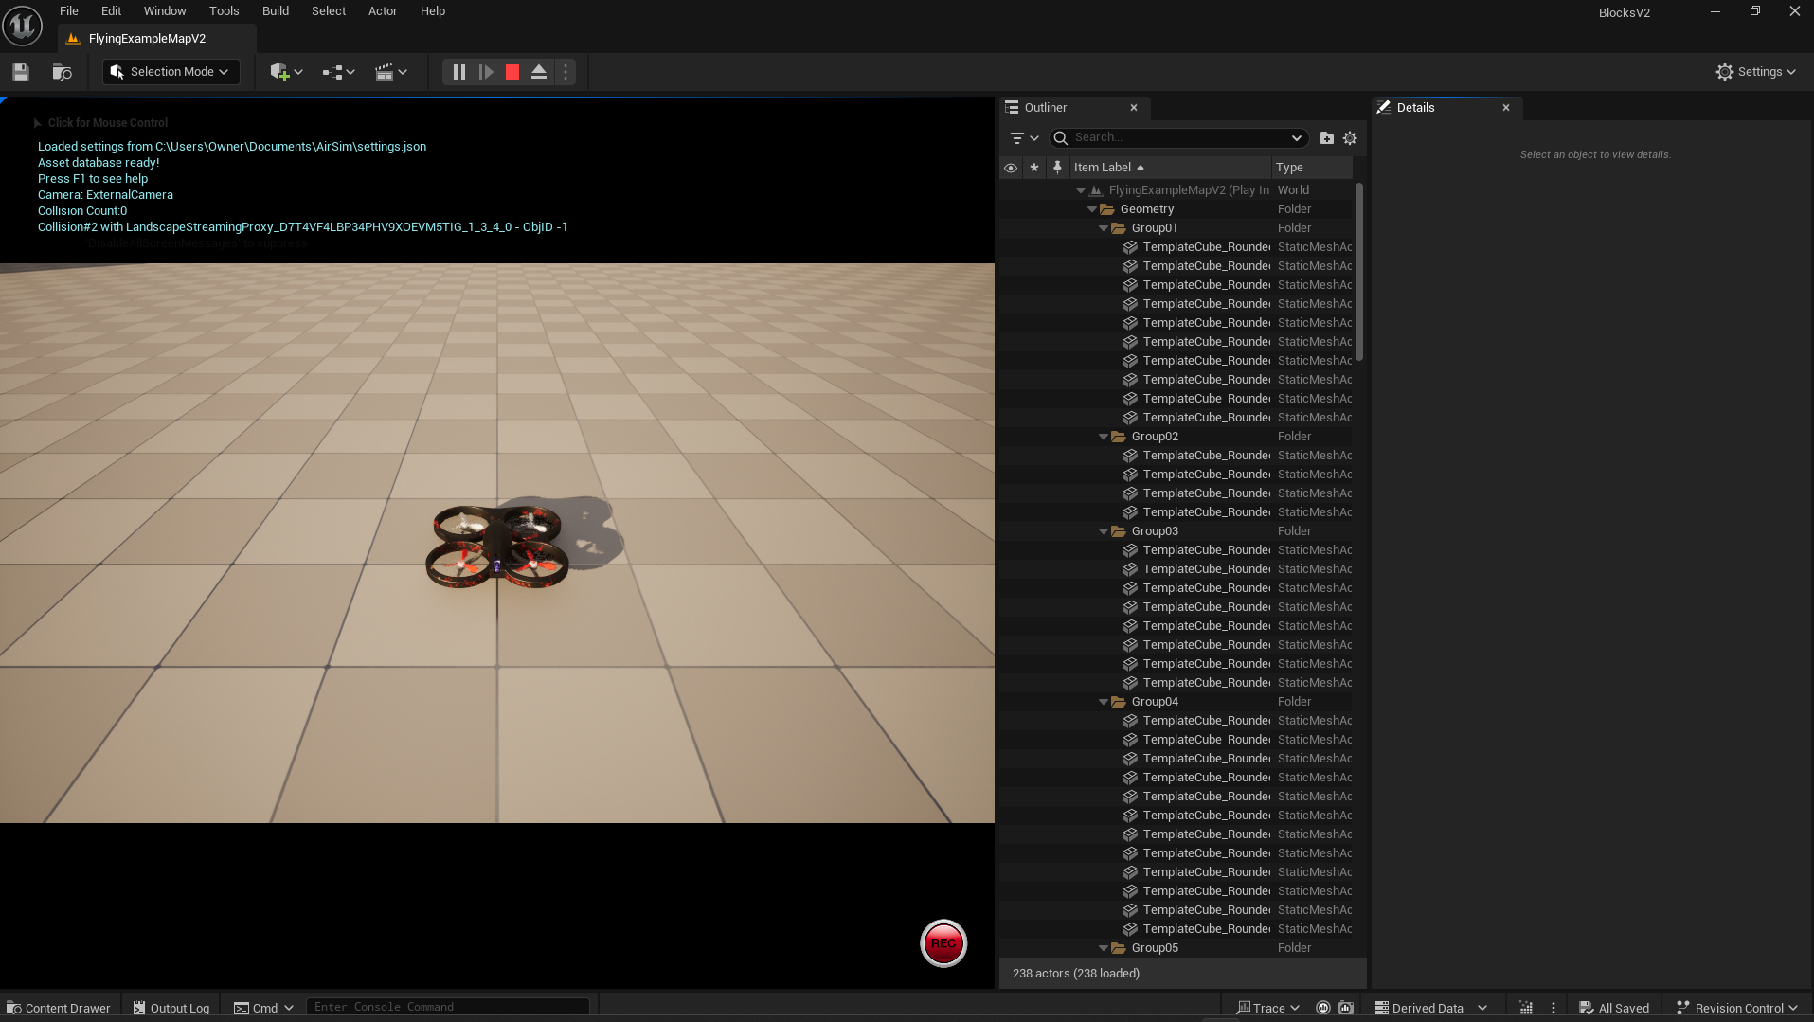

1. In the Anaconda Powershell Prompt, navigate to *Colosseum\PythonClient\multirotor*.

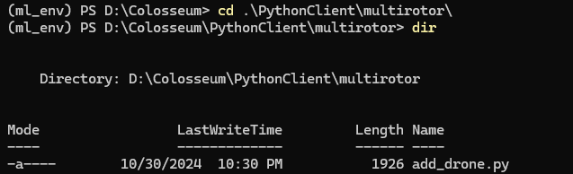

1. Run **python add_drone.py**. You should now see two drones.



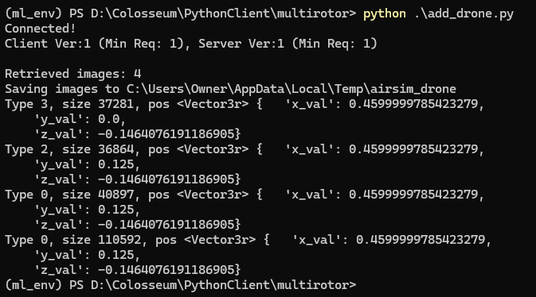

You can create and modify different drone scripts to run in the simulator. They do not necessarily have to be in the *PythonClient\multirotor* directory, but it is easier to keep every script together in a memorable place.

Here’s an example of running [*semi_descent.py*](https://drive.google.com/file/d/1UKNx4lHpKPWfYeB8wu68GOKZgtUvaqb_/view?usp=drive_link) found in the Google Drive:



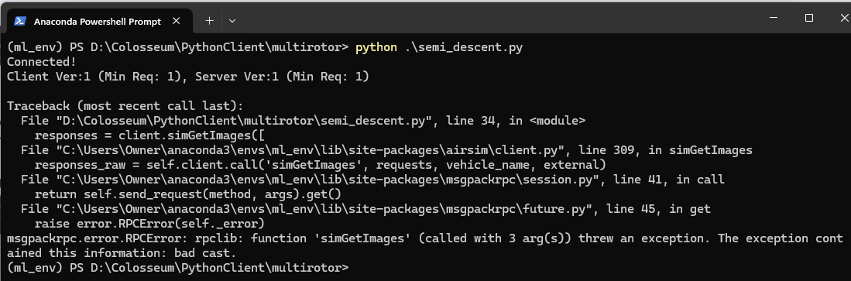

## **Simulator Performance**

To improve performance of Unreal Engine when running scripts, go to **Edit → Editor Preferences → Performance**. Uncheck **Use Less CPU when in Background** to increase performance while Unreal is in the background.

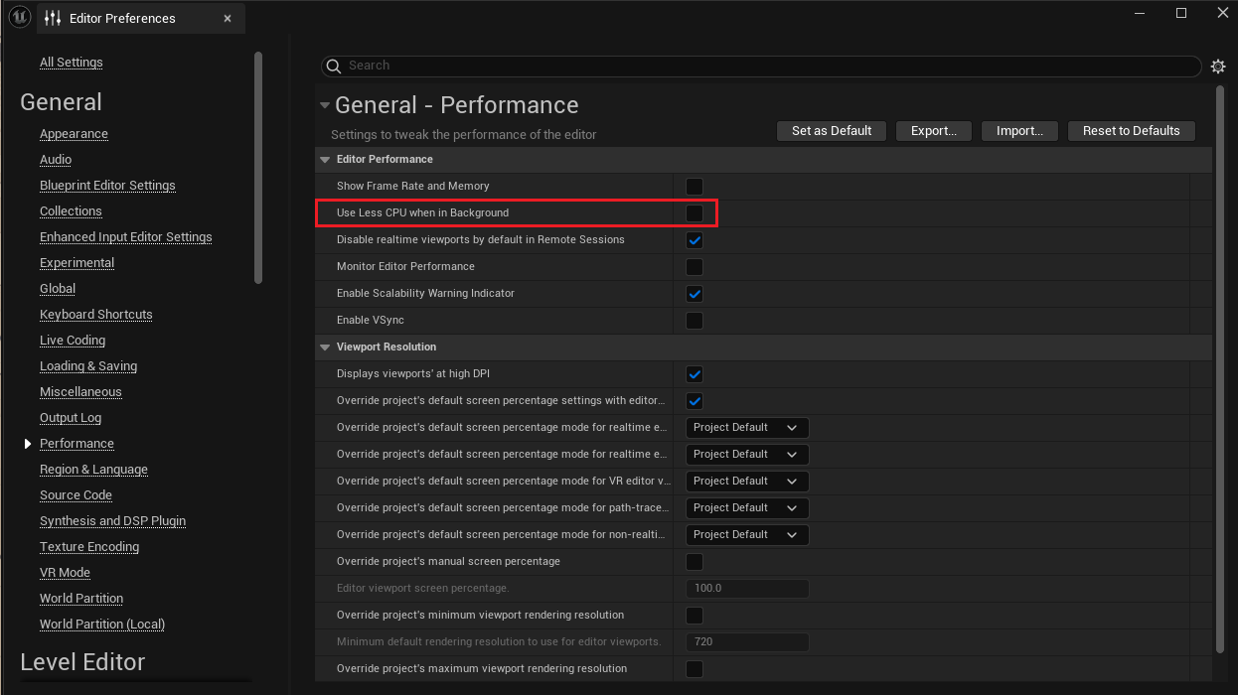

# **Part 2: Docker Container for ROS and Pytorch**

This part assumes you have completed Part 1: ML Environment + Simulator. You should be able to run the sample Blocks project and run the **add_drone.py** script to interact with Colosseum.

## **Ethan’s Repo**

Clone Ethan Adkin’s repository into *Colosseum\PythonClient\multirotor*. It is highly recommended to clone it in the *multirotor* directory. You can clone the repository with Powershell or with Anaconda Powershell.

* **git clone** [**https://github.com/EthanAdkins/LM01-Drone-SAR.git**](https://github.com/EthanAdkins/LM01-Drone-SAR.git)



## **Docker**

Install Docker for Windows: <https://docs.docker.com/desktop/install/windows-install/>

Create an account for Docker. Make sure to login when installing Docker Desktop.

Download the most up-to-date Dockerfile from Google Drive ([Dockerfile-ROS-Pytorch-Latest](https://drive.google.com/file/d/1vgymouw7D59FOcH7tPYl-pPhAyq_XGbF/view?usp=drive_link)). Drag this Dockerfile into *Colosseum/tools*.

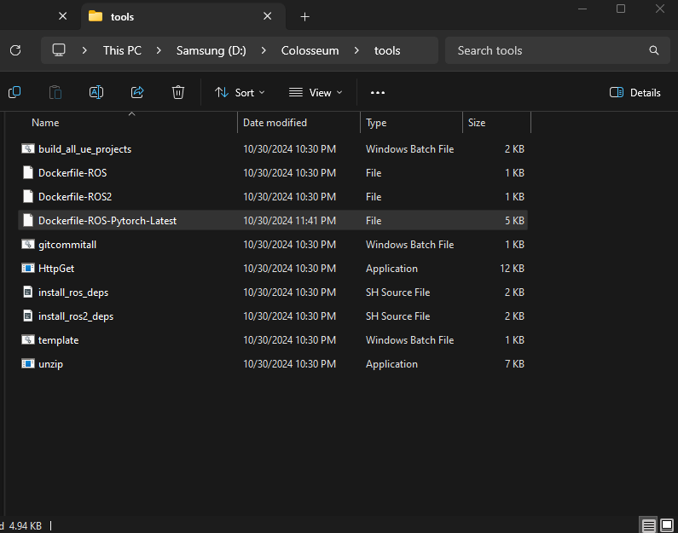

## **Build and Run Container**

Open an Anaconda Powershell Prompt and activate the Conda Virtual Environment with **conda activate ml_env**.

Navigate to *Colosseum\tools*.

Run: **docker build -t airsim-ros-pytorch-latest -f Dockerfile-ROS-Pytorch-Latest .**



* The space and period at the end are required!!! The dot refers to the current directory.
* Building the Docker container may take a while.
* If this errors due to the Docker daemon not running, start Docker Desktop to start the Docker Engine.
* If this errors on Line 22: Open **install_ros_deps.sh** in the tools folder with an IDE. Convert the EOL from CRLF (Windows) to LF (Unix). In VSCode, you can click to change the EOL at the bottom:

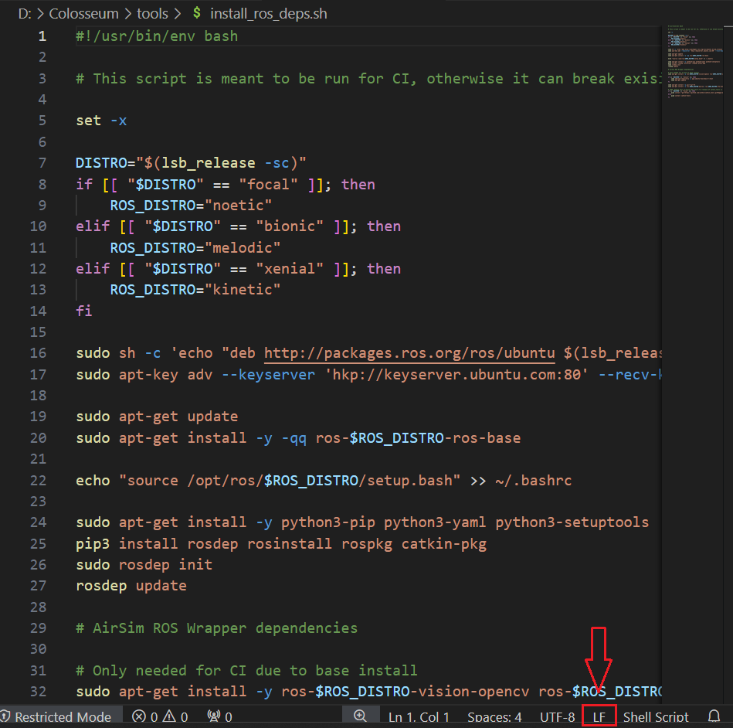

Once the build completes, run it with the following command: **docker run --rm -it --net=”host” -v //d/Colosseum:/home/testuser/AirSim airsim-ros-pytorch-latest:latest bash**

* The format after -v is *<your-AirSim-folder-path>:/home/testuser/AirSim*. Use your personal directory location for AirSim/Colosseum
* If Colosseum is in the C: drive, then use C: instead of //c.

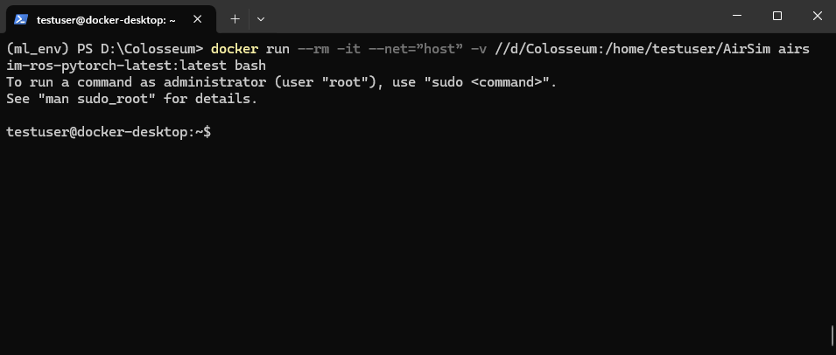

# **Part 3: Setup ROS in Docker Container**

When first running the container, run the following commands:

* **echo "source /opt/ros/melodic/setup.bash" >> ~/.bashrc**
* **source ~/.bashrc**

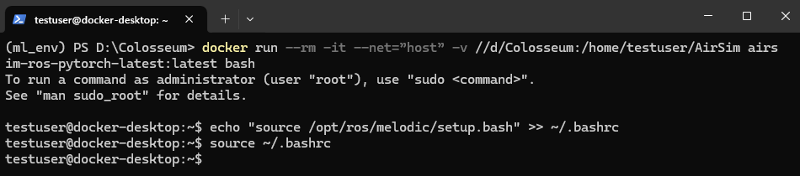

In Windows File Explorer, navigate to *Colosseum/ros/src/airsim_ros_pkgs*.

Download each of the .srv files in the [ROS Server Files folder](https://drive.google.com/drive/folders/1IRzDVqSOr0pjeDiRGzGUDUMKO7zFv6OF?usp=drive_link) in Google Drive. Place the files in the *srv* directory.

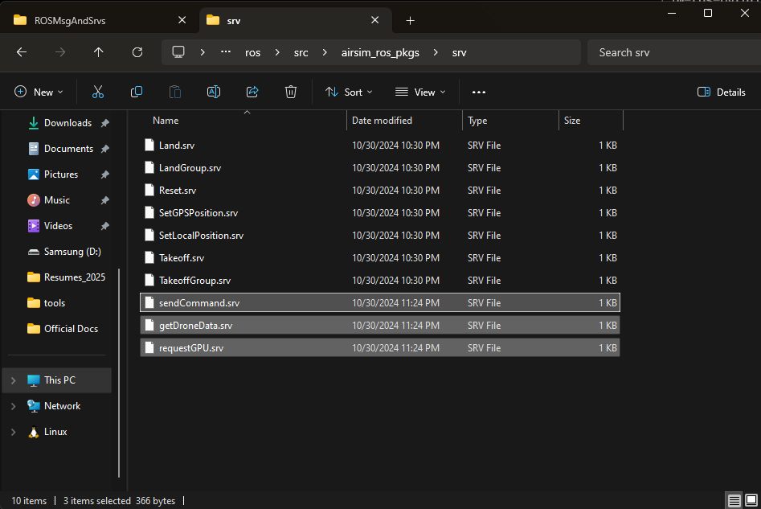

Download each of the .msg files in the [ROS Message Files folder](https://drive.google.com/drive/folders/1wTwlqovrB5UvEO-aRx9wxCrRrSpAoLgO?usp=drive_link) in Google Drive. Place the files in the *msg* directory.

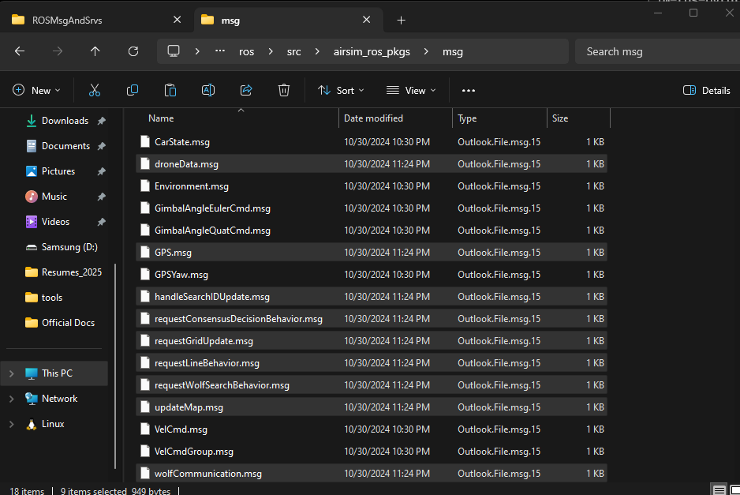

**Note:** The .msg and .srv files can also be found in *Colosseum/PythonClient/multirotor/LM01-Drone-SAR/needsIntegration/ROSMsgAndSrvs*

Replace the CMakeLists.txt file in *airsim_ros_pkgs* with the [CMakeLists.txt](https://drive.google.com/file/d/1dY4koKyxdGIik8BAI9hUSVPSnfEWRky3/view?usp=drive_link) in Google Drive.

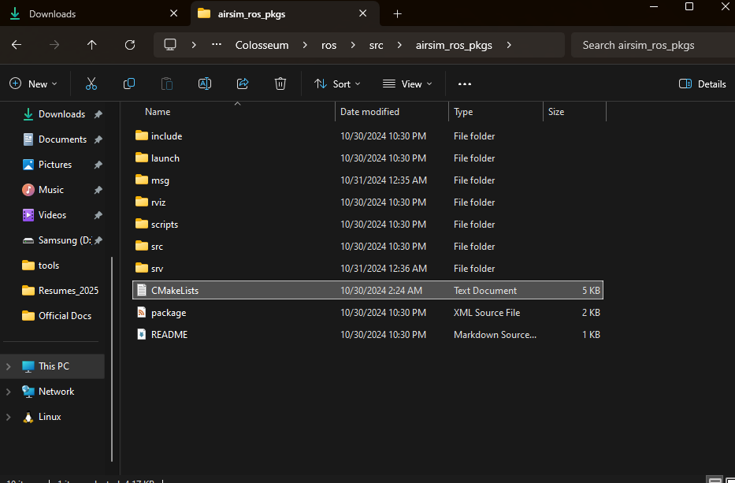

Now in the running Docker container, navigate to *AirSim/ros* and run: **catkin build -DCMAKE_C_COMPILER=gcc-8 -DCMAKE_CXX_COMPILER=g++-8**

* If this produces an error mentioning rpclib, you did not run the correct *build.cmd* when building Colosseum. Replace the *build.cmd* in Colosseum with the one in the Google Drive and the run **build.cmd**
* If there are any other errors, it is likely you didn’t run the following commands when starting the container:
  + **echo "source /opt/ros/melodic/setup.bash" >> ~/.bashrc**
  + **source ~/.bashrc**
* This build may take a while. It will produce some warnings, but will still say the build was successful.

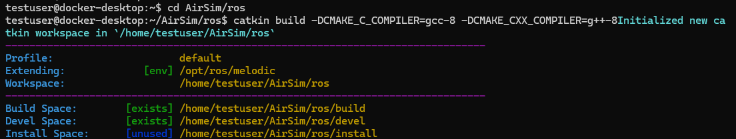

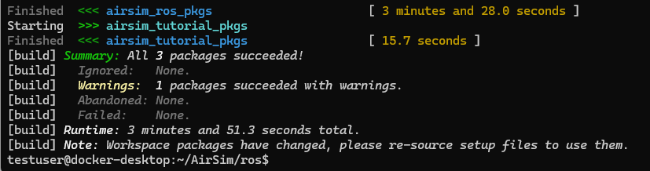

Next, run **source devel/setup.bash**

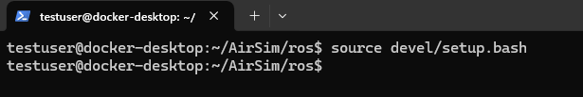

Then, run these installs (Most likely already done, but doesn’t hurt):

* **pip3 install numpy**
* **pip3 install msgpack-rpc-python**
* **pip3 install --upgrade pip**
* **pip3 install opencv-python**
* **sudo apt install iproute2**

Finally, run: **ip addr | grep global**. Take note of the IP address for docker0.

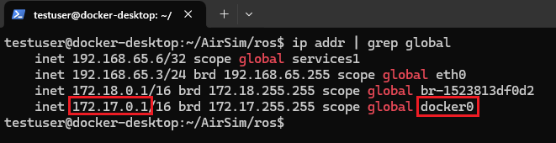

Now in a new Windows Terminal (Powershell), type **ipconfig**. Record the IP address with the WSL (HyperVee Firewall) tag.

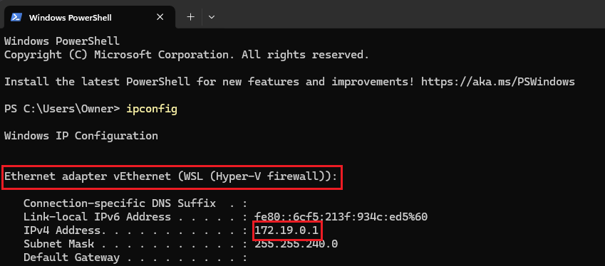

Download [*settings.json*](https://drive.google.com/file/d/1nPyYySA8jh4PfODczqkS4HxK8BS1ny3O/view?usp=drive_link) from Google Drive. In your choice of IDE:

* Replace every IP under *ControlIp* with the IP of docker0
* Replace every IP under *LocalHostIp* with the IP of Windows (WSL tag)

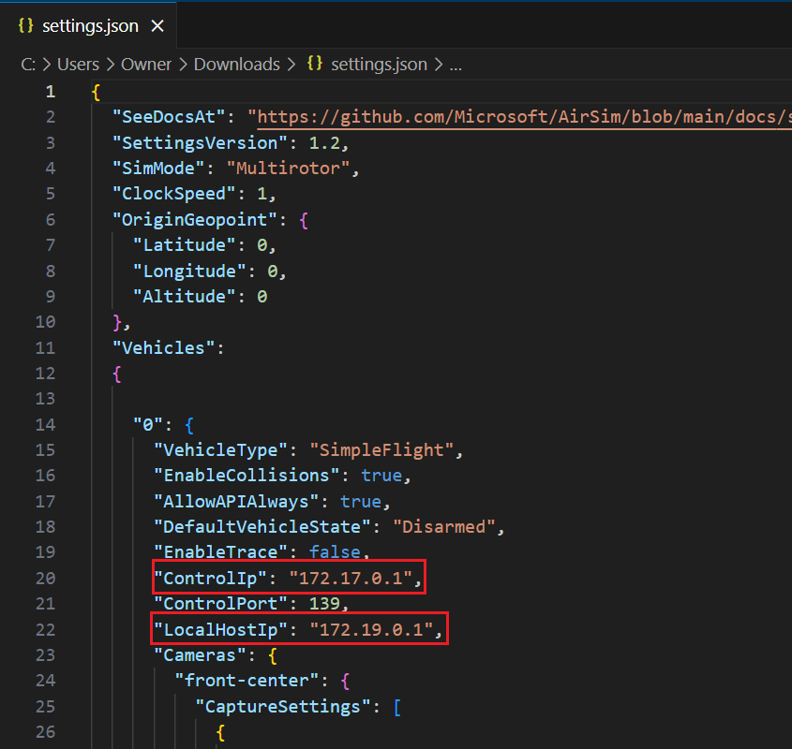

**Note:** There should be a *ControlIp* and *LocalHostIp* under each of the *Vehicles* in *settings.json* (5 total vehicles).

Replace the default *settings.json* that is under *C:/…/Documents/AirSim* with the one you just modified.

* This is specifically in your main drive’s Documents folder. It could also be in *OneDrive/Documents/AirSim*.

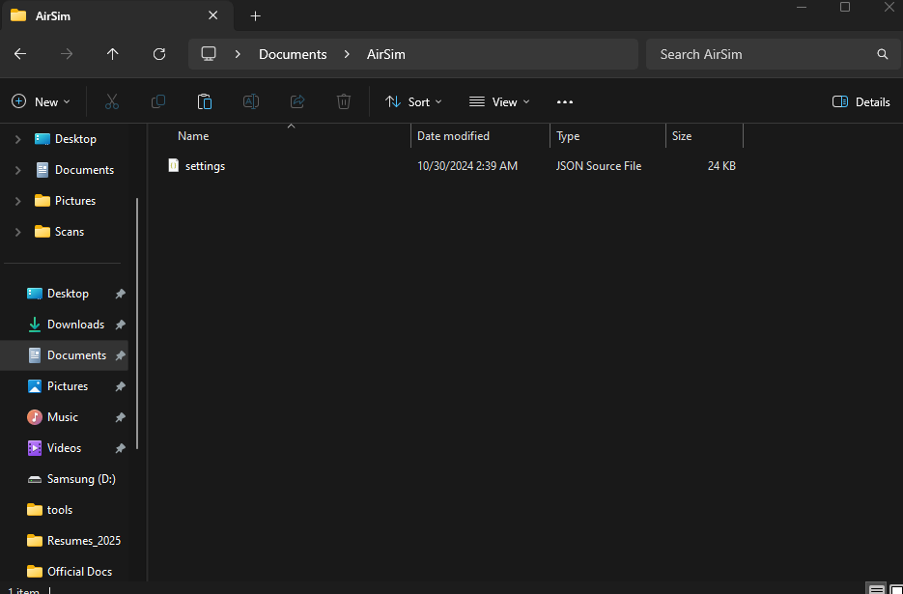

Finally, back in the docker container, run **export ROS_HOSTNAME=172.17.0.1**, replacing the IP address with the IP of docker0 (should be the same for all of us)

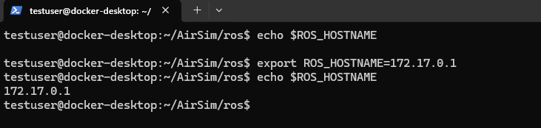

# **Part 4: Testing ROS**

Now it is time to test if ROS is set up correctly.

Download [*startMultiDrone.py*](https://drive.google.com/file/d/1awl-v2uiXn8yAvTk_X97Z8LrDHKardPo/view?usp=drive_link) and [*droneNode.py*](https://drive.google.com/file/d/1MDy9IAiC8l9CutRcj6h_43boPkQn_7MT/view?usp=drive_link) from Google Drive. Place these files wherever you want in the AirSim/Colosseum repo (preferably under the *PythonClient/multirotor* directory).

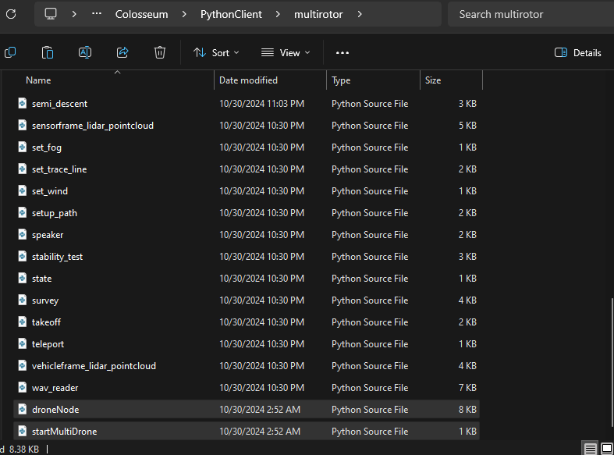

**Note:** Each Python program you run, you must make sure to modify the LocalIP to be your Windows WSL IP from above.

Change the LOCAL_IP of *droneNode.py* (Line 24) to be your Windows WSL IP.

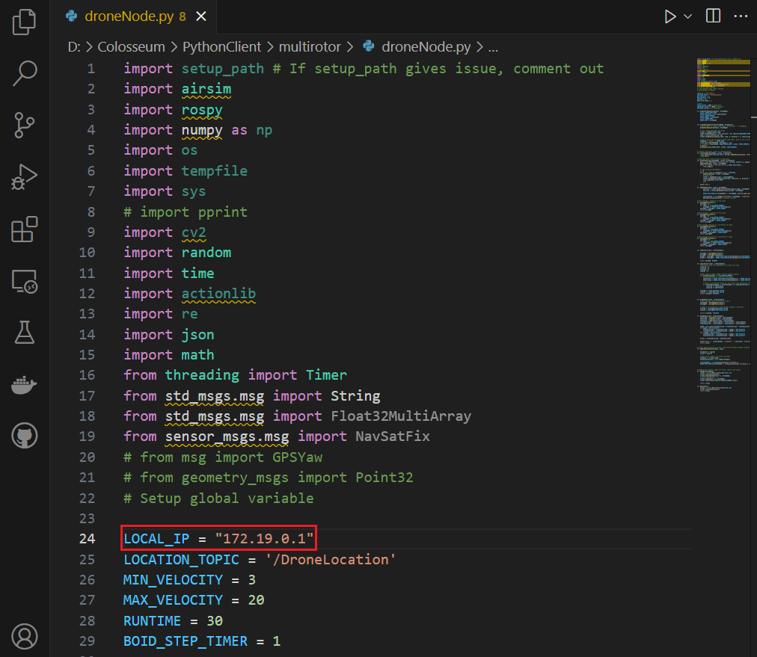

Now it is time to run the application. You will need two terminals: one for running the ROS scripts and another for running *startMultiDrone.py*.

Open two separate Anaconda Powershell Prompts. activate your virtual environment and run the docker container in each.

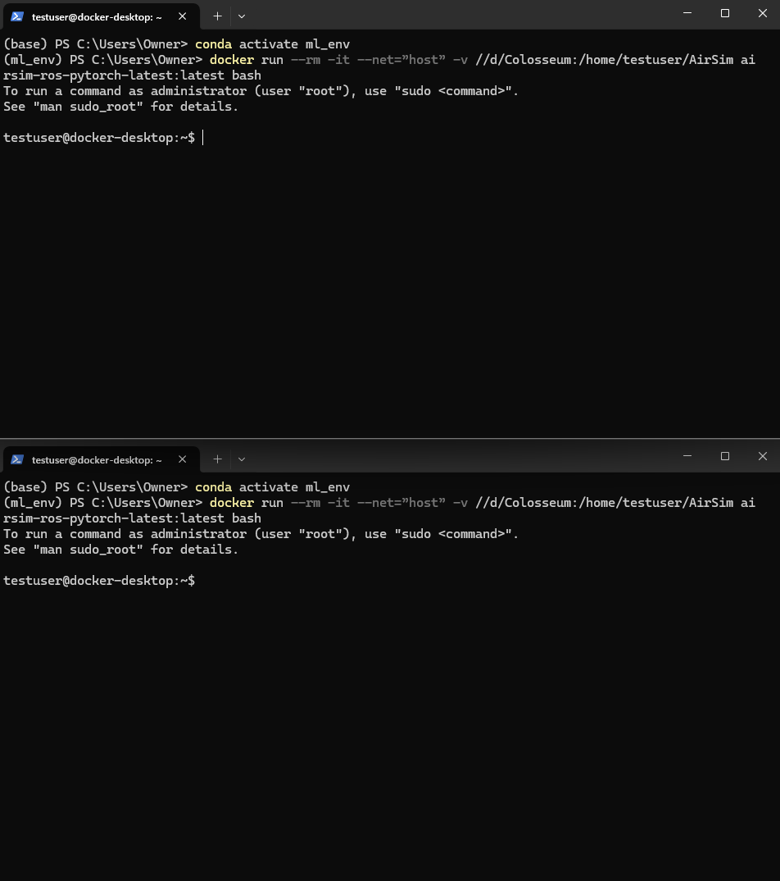

Every time you run the container, you must run the following commands:

* **echo "source /opt/ros/melodic/setup.bash" >> ~/.bashrc**
* **source ~/.bashrc**
* **export ROS_HOSTNAME=172.17.0.1** (your docker0 IP)
* **cd AirSim/ros**, then **source devel/setup.bash**.

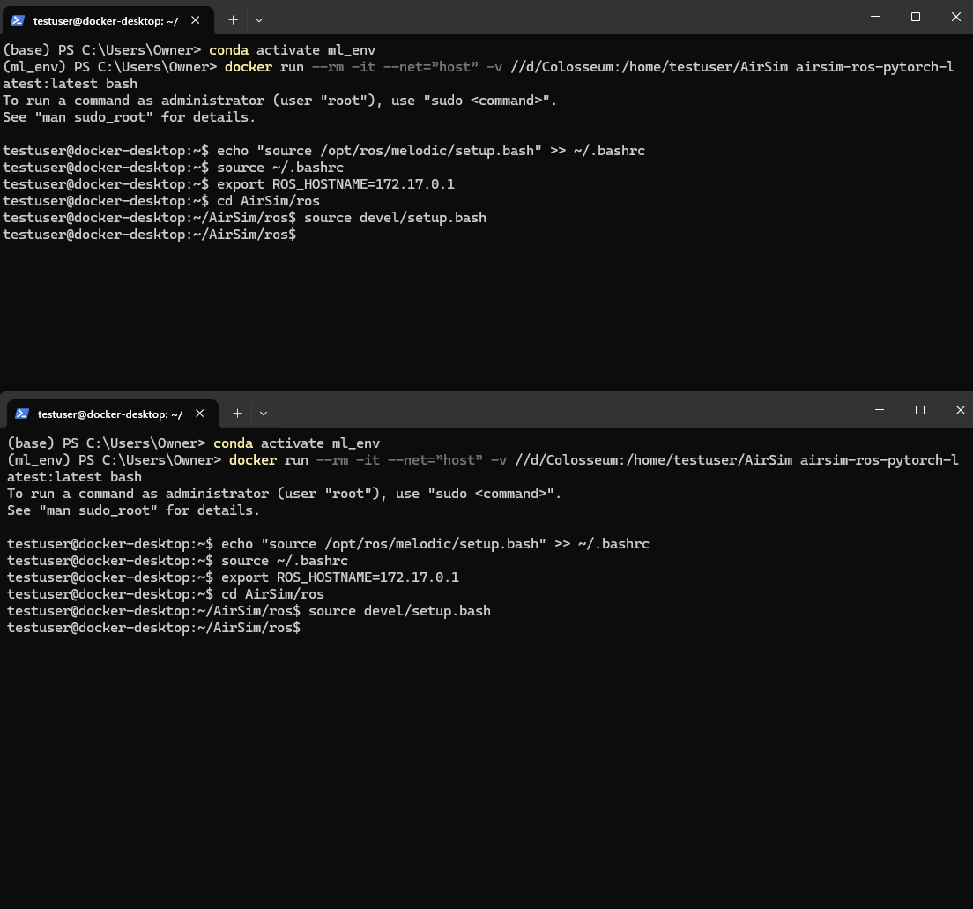

In the first terminal, run **roslaunch airsim_ros_pkgs airsim_node.launch**. This will launch a ROS server.

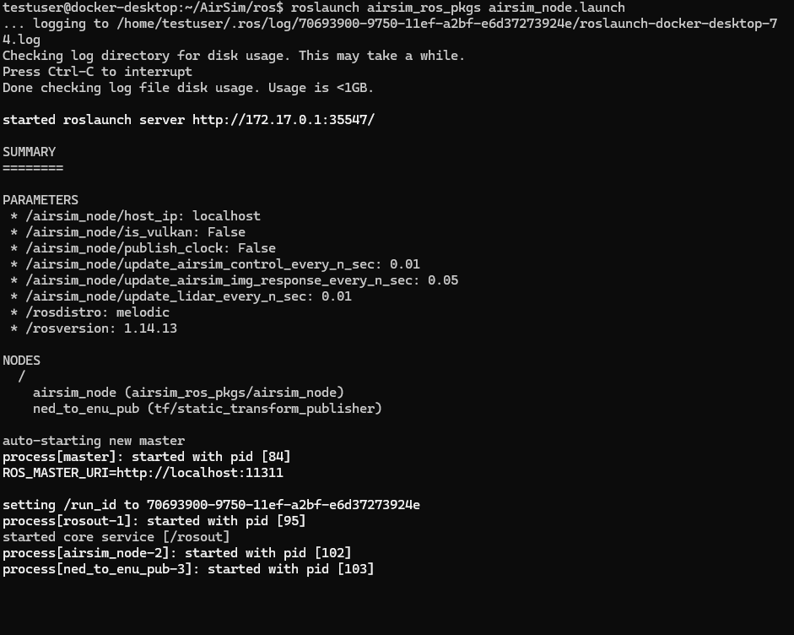

Next, start up the simulator. Open the BlocksV2 project from before. You will notice that there will be 5 drones spawned and 3 drone image sensors on the bottom (this is from the *settings.json* configuration earlier)

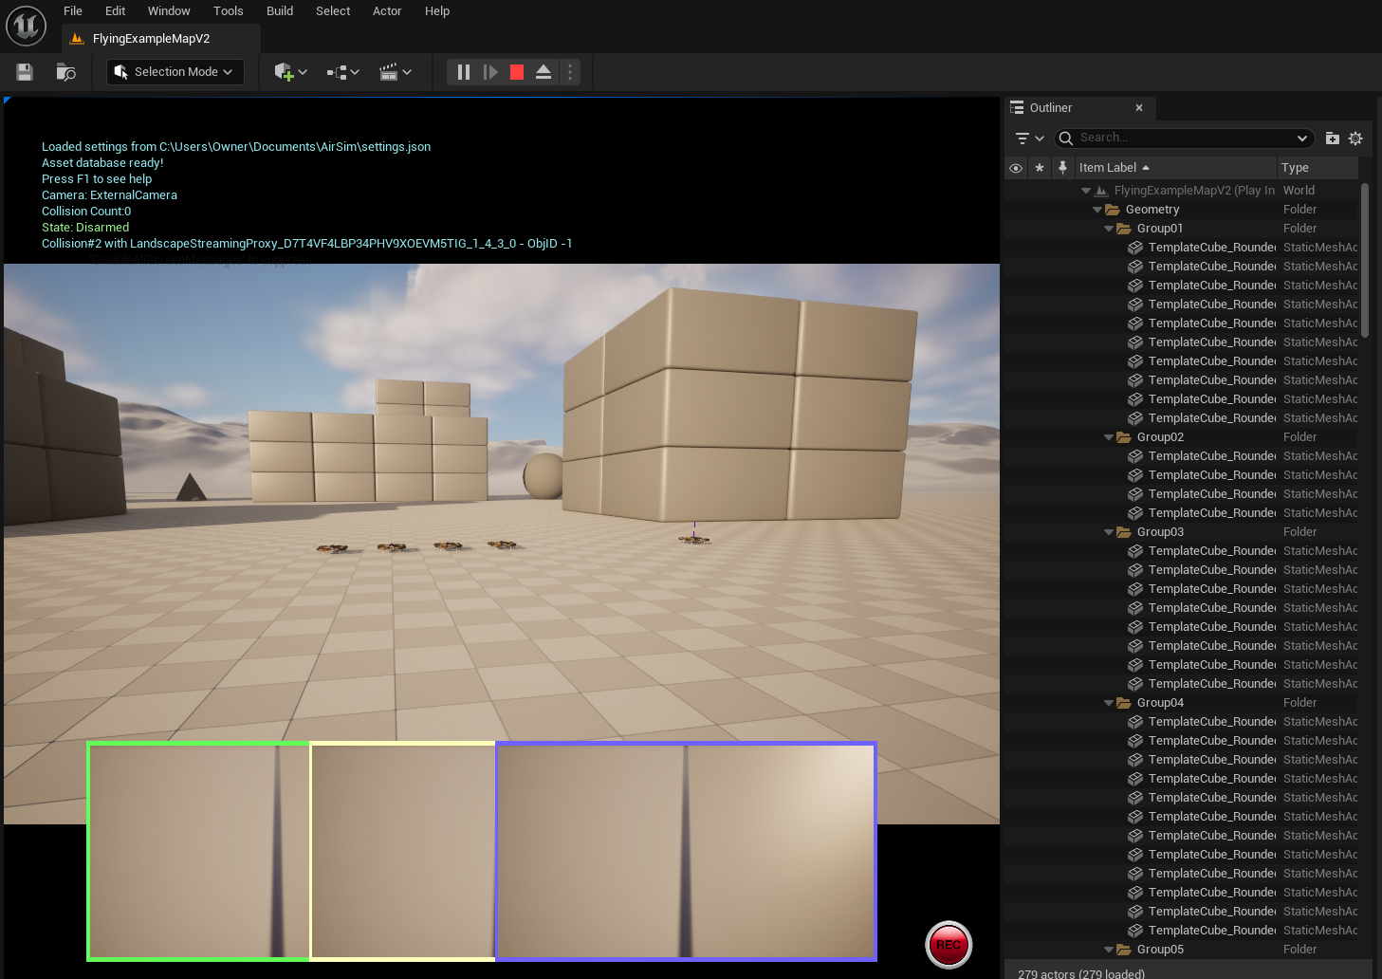

Now in the second terminal, navigate to *AirSim/PythonClient/multirotor* and run **python3 startMultiDrone.py**



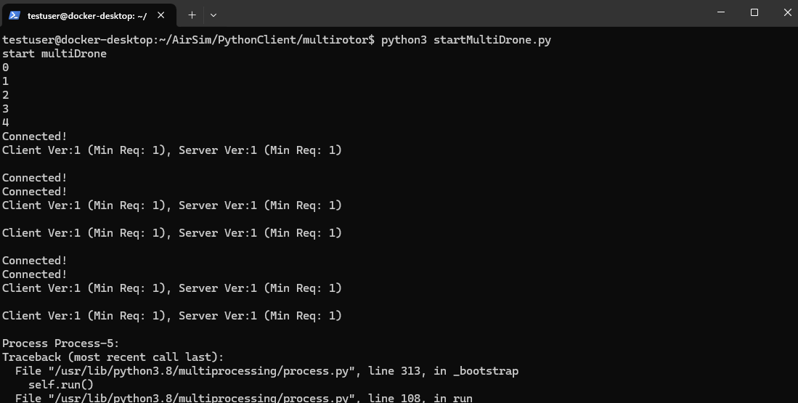

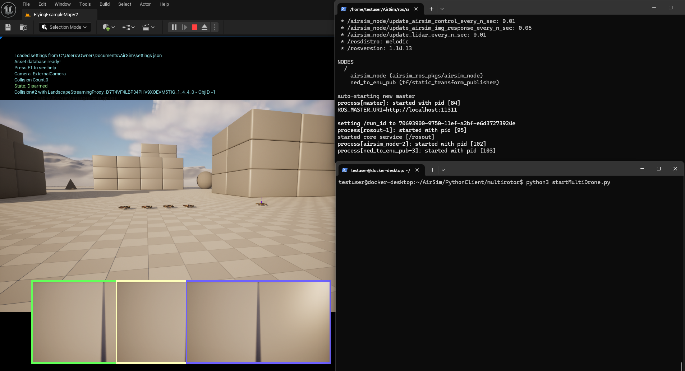

# 

# **Important Notes**

Every time you run the container, you must run the following commands:

* **echo "source /opt/ros/melodic/setup.bash" >> ~/.bashrc**
* **source ~/.bashrc**
* **export ROS_HOSTNAME=172.17.0.1** (your docker0 IP)
* **cd AirSim/ros**, then **source devel/setup.bash**.

The process to run a specific Python script:

* Open up two Anaconda Powershell Prompts, activate the virtual environment, and run the docker container.
* In both terminals, run the startup commands (listed above)
* In one terminal run **roslaunch airsim_ros_pkgs airsim_node.launch** to launch the ROS server.
* In the other terminal, navigate to the script you want to run. Run the Python script with either python or python3.

# **References**

[Ethan’s ML Environment + Colosseum Setup](https://docs.google.com/document/d/13fzBkXq9ez_11_gfZe0GdHdRxH3r3OBAR-FbDXjze2U/edit?usp=drive_link)

[Ethan’s ROS Setup](https://docs.google.com/document/d/1vvky-ozK_3ut_0SM6wjK7rriHi6quO4e_tpZT5pXSok/edit?usp=drive_link)

[Microsoft AirSim Documentation](https://microsoft.github.io/AirSim/)

[Colosseum Repo](https://github.com/CodexLabsLLC/Colosseum)